**A CHATBOT FOR MENTAL HEALTH SUPPORT IN KENYA**

1. Emmanuel Chesire
2. Stanley Njoroge
3. Dedan Okware
4. Lennox Mwita

**Introduction**

Mental health disorders such as depression and anxiety affect millions of people worldwide and can have significant impacts on individuals, families, and communities. They can cause physical health problems and have economic costs. Despite this, many people do not receive the treatment they need, with less than half of people with depression and one-third with anxiety receiving treatment. Addressing mental health is critical for overall well-being through increased awareness, reduced stigma, and improved access to care.

## **BUSINESS UNDERSTANDING/**

### PROBLEM

Health experts in Kenya face challenges such as lack of resources, stigma and shortage of trained professionals when addressing mental health issues.In Kenya, there is a significant shortage of mental health professionals. According to the World Health Organization, there are only 0.19 psychiatrists, 0.03 psychologists, and 0.02 social workers per 100,000 people. This is far below the recommended minimum of one mental health worker per 10,000 people.As a result, mental health patients often struggle to access care. The Kenya Ministry of Health estimates that 25% of the population requires mental health services, but less than 10% receive them. Additionally, only 10% of health facilities provide mental health services, and these services are concentrated in urban areas, leaving many rural populations without access to care.

### THE NEED TO DEVELOP A VIRTUAL ASSISTANCE FOR MENTAL HEALTH SUPPORT

Due to the above mentioned problems developing a virtual assistance for mental health support can have significant benefits. With the increasing use of technology, a virtual assistant could provide accessible and convenient support to individuals in need of mental health information and resources.Virtual assistants could provide information on mental health disorders, symptoms, and treatment options, as well as connect individuals with mental health professionals or support groups. They could also offer personalized support, such as reminders to take medication or practice self-care.Moreover, virtual assistants could help reduce the stigma surrounding mental health by providing anonymous and confidential support. Individuals who may feel uncomfortable seeking help in person or over the phone could access mental health information and resources from the comfort of their own homes.Developing a virtual assistant for mental health awareness could also help address the shortage of mental health professionals in many areas. With a virtual assistant, individuals could access support and resources without needing to wait for an appointment with a mental health professional. In conclusion, developing a virtual assistant for mental health support has the potential to improve mental health outcomes by increasing accessibility and reducing stigma.

CLIENT ENGAGEMENT PROCESS

The user engagement process is defined by the following steps which will ensure a user-centered virtual assistant is developed.

1. Defining target audience – This includes identifying the specific group of people who will be using the virtual assistant.
2. Understanding user needs – After defining the target audience, we need to understand their needs and preferences.
3. Define virtual assistant purpose – Based on the user needs we need to define its purpose, what task it will perform.
4. Create a user-friendly virtual assistant – This involves creating a chatbot with a good user interface which will facilitate easy interactions with the user
5. Provide excellent services – The chatbot should be able to perform its task correctly.
6. Continuously improve the virtual assistant – improvements should be done on the assistant in order to meet changing user needs.
7. Measure user engagement – Measuring the engagement helps to determine whether the

system was effective or not.

### OBJECTIVES

1. To develop a user support Virtual Assistant for Mental Health Support
2. To deploy the virtual assistant for the Mental Health Support into a web interface to enhance user experience.
3. To develop online virtual assistance using machine learning which can be able to answer inquiries and user queries quickly and efficiently.

## **DATA ACQUISITION**

## SOURCES OF DATA

To understand the problems regarding mental health, what mental health patients go through and the appropriate responses that can assist them, we corrected data over several channels on the internet. These included blogs and psychological youtube videos. The blogs included those of the World Health Organization, National Institute of Mental Health, Centers for Disease Control and Prevention and researchers conduct studies on mental health to understand the prevalence, causes, and treatment of mental health disorders. We also engaged with our local university counseling teams to help us gain understanding on the same matter.

### DATA ACQUISITION PROCESS

After identifying our data sources, we were able to come up with a process which would enable us to get as much information from the data as possible. We used the Extraction Transformation and Loading (ETL) tool, this is a process used in data acquisition to collect and move data from different sources, transform the data to make it compatible with the destination system, and load the transformed data into the target system. The first step was extracting the data from the text files which were obtained from blogs. We were able to separate useful information which was necessary for training our model from other information. We then transformed the data from text files into a JSON file which was an appropriate data format for our model. The final step was loading the data into our systems for use in training the model.

## **EXPLORATORY DATA ANALYSIS**

EDA is the process of analyzing and summarizing the main characteristics of a dataset. Its purpose is to explore the topic patterns of the blogs.

The main variable of interest is the message content.

The EDA techniques used included exploratory visualizations, to analyze the trends of the frequently addressed problems over the years.

### EXPLORATORY DATA ANALYSIS PROCESS

### Data cleaning and preprocessing – We cleaned the data to remove the duplicates, stop words and some of the inconsistencies.

### Identifying patterns – This involves identifying related words and phrases and analyzing some of the relationship between different responses and the mental health problems as well as actions taken.

### Feature selection – This involved selecting important features that were used to train the chatbot. This involved selecting some of the most frequent phrases and words to train our model.

### Visualizations – This includes use of histograms and box plots to examine the distribution of message type across different intents.

### Word frequency analysis – A bar chart was used to identify the most common words and phrases used in different datasets from the blogs.

### EXPLORATORY DATA ANALYSIS OUTCOME

## **DATA CLEANING**

We used intents which involves categorizing the data into different intents or categories and then performing cleaning operations on each intent separately.

### DATA CLEANING PROCESS

* We first went through the datasets from the blogs and identified the intents of each blog such as Stress management
* Categorized the data into different intents
* Created a JSON file and each intent had a tag, pattern and response
* Identified duplicated patterns and response and removed unnecessary characters and formatted the data
* We went through the entire datasets available line by line highlighting and extracting key information related to Mental Health such as words and questions and their respective answers or actions.

### DATA CLEANING OUTCOMES

* We were able to acquire a dataset that only contained Metal Health related issues only. The dataset was then used to create a JSON file which was used to solve the problem.
* Improved data quality: we removed errors, inconsistencies, and irrelevant data which made it more reliable for the next step.

## **FEATURE ENGINEERING**

Feature engineering is the process of selecting and transforming raw data into features that can be used to train a machine learning model.

### FEATURE ENGINEERING PROCESS

After doing the data cleaning process and transforming data in a format of inbound and outbound text. The inbound text contained problems faced by mental health patients while the outbound texts contained responses and advice of action given to the patients by mental health professional experts. This enabled us to remain with the problems the patients are most likely to experience in our training set.

These steps were followed for the feature engineering process

1. Converting data to lowercase

Converting data to lowercase is one of the useful preprocessing steps before training a chatbot. This ensures consistency by ensuring that all training data was represented in a consistent way. Consistency helps the chatbot to better recognize words and phrases by reducing the number of errors that may occur due to case sensitivity. Converting data to lowercase also reduces the dimensionality of the data and ensures that the chatbot predicts the output with high speed.

2. Tokenizing of data

Tokenization is the process of breaking text into smaller units called tokes. We broke down the words and phrases into smaller units this transformed the data into a structured manner. For tokenizing our data, we used a word tokenization which involves breaking words into text. By breaking words into individual tokens, the algorithm was able to analyze text more effectively by identifying more frequent words and even helping the model predict the next word with high accuracy.

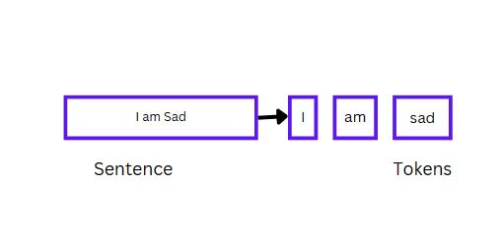

3. Removing punctuation

This was a very important step which included getting rid of punctuation marks such as periods, commas, or exclamation marks. These punctuation marks can add noise to data, as they are often used for stylistic purposes and rather than conveying meaning. By removing this punctuation, the text data becomes cleaner and more focused on the important content.

4. OneHotEncoding

One hot encoding is one of the important techniques used in machine learning which is common in training of chatbots. It involves representing categorical variables in words to binary features. OneHotEncoding was useful in training our chatbot, it allowed the model to represent words in an easier way to process and analyze. This enabled the model to recognize specific words which can then be used to generate an appropriate response to the user.

5. Lemmatization

Lemmatization is a technique in Natural Language processing which is useful for training chatbots. It involves reducing words to their base form, which is the root form. For example, the base word for the word “changed” is change. Lemmatization was key in reducing the dimensionality of our data by grouping related words that have the same base word together. This made the chatbots’ training data more manageable and efficient to process.

6. Limiting each question to a length of 50 words

Reducing the number of words in each question in the training set helped in improving the speed and efficiency of the process. This is because fewer words that need to be processed, the less time and resources the model will require.

### FEATURES USED

Features refer to the individual measurements or attributes that are used to describe or analyze a dataset. These features are then used to train the machine learning models to recognize patterns and make predictions based on their input data. In training our model we used categorical features which were then one-encoded to numerical values.

**Intents**

Intents are actions which the user intents to do. It simply describes what the user intends to ask about. This helps in classifying and figuring out what the user wants to ask about and grouping them in one class of related questions.  Intents are important features for the development of the model, when the user sends a message to the chatbot, the chatbot identifies the user intents in order to respond appropriately. We created a set of several intents for the dataset used in training, the intents were based on the kinds of questions or requests that the users are likely to have.

**Patterns**

This contains a list of strings, where each string represents a message or a phrase that a user might ask. Related patterns should be grouped together in one intent this enables the model to put together a group of words and map them with their corresponding response. Patterns are generally questions which might have been asked by the user Patterns are crucial features in training a chatbot as enables it to identify user intents. By creating several well-crafted patterns for each intent, we ensured that the chatbot can accurately recognize and respond a wide variety of user questions.

**Responses**

Responses refer to features which contain a set of messages or phrases that the chatbot is programmed to say or display when it recognizes a specific intent from the user. They are used to provide an appropriate and helpful reply to the user questions. When collecting and cleaning the data we defined a set of responses for each intent that the chatbot is meant to recognize. These responses are variations on the type of messages that the chatbot might want to send back to the users’ question

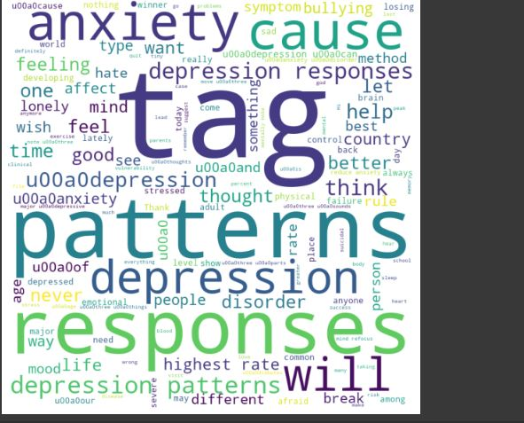

## **MODEL DEVELOPMENT**

The model development approach chosen is a supervised learning approach. It involves providing the computer with labeled data, which includes input data and the corresponding desired output. The computer then uses this data to learn a model that can be used to map new input data to the desired output. This model can then be used to make predictions on unseen data, and to classify data into different categories.

### JUSTIFICATION FOR MODEL USED

The model was useful because it could be used to make predictions on unseen data, and to classify data into different categories. It was an effective way of using labeled data to train a machine learning algorithm to make predictions on unseen data. Furthermore, it was a supervised learning approach, which means that the computer was given both the input data and the corresponding desired output, thus ensuring accuracy and reliability.

## **MODEL EVALUATION**

Machine learning models are evaluated by use of metrics. A metric is a measure of something that can be used to track and compare performance. Metrics can be used to measure and compare performance and progress. They provide an objective way to measure and compare progress in order to make informed decisions and identify areas for improvement.

### METRICS USED

The following types of metrics were applied:

1. Precision

Precision metric is a measure of accuracy and consistency in a model. This metric was used to assess how accurately our model was able to predict the true value of a target variable. Precision measured how many of the predictions made by the model were correct. The higher the precision, the more accurate the predictions of the model are.

2. F1-score

The F1-score is a metric that combines precision and recall into a single score. This metric was used to assess the overall performance of a model. The F1-score takes into account both precision and recall to give an overall measure of how well a model is performing. The higher the F1-score, the better the performance of the model.

RESULTS FROM DIFFERENT METRICS

Accuracy

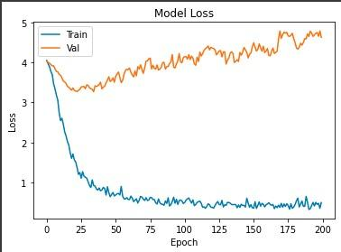

### JUSTIFICATION FOR METRIC USED

The precision, recall, and F1-score metrics are useful for assessing the performance of a model. Precision measures how accurately the model is able to predict the true value of the target variable, while recall measures how many of the true values the model is able to identify. The F1-score combines these two metrics into a single score, allowing for a more comprehensive assessment of the model's performance. These metrics were useful for evaluating the model and helped to identify areas for improvement.

## **MODEL DEPLOYMENT**

Model deployment in machine learning refers to the process of integrating a trained machine learning model into a production environment, where it can be used to make predictions or perform other tasks in real-time. Model deployment is the final step in the machine learning pipeline, and it involves making the model available to end-users or other systems that can make use of its outputs.

### DEPLOYMENT METHOD USED

We used flask for our model deployment because it is a lightweight web application framework that is commonly used for deploying machine learning models. Flask allows a trained model to be deployed in a web page which can then be accessed online by different users. Flask incorporates CSS, HTML and JavaScript to come up with interactive web pages.

### PROCESS OF MODEL DEPLOYMENT

* Installed Flask using pip: pip install flask
* Created a Flask application: we did this by creating a new Python file, and imported the Flask module. Then, created a new instance of the Flask class and defined a route for the application.
* Created a new Python file and imported the necessary modules such as pandas, sklearn for the machine learning model. Defined the model and loaded the necessary data.
* Created a new route in the Flask application that used the machine learning model to make predictions. We created a route that takes input data from a POST request and returns a JSON response with the predicted value.
* We saved the Python files and ran the Flask application using the following command in the command prompt:

export FLASK_APP=app.py

flask run

* Tested the model: Used an HTTP client test the model by sending a POST request to the /predict endpoint with the input data in JSON format
* The Flask application therefore receives the request, uses the machine learning model to make a prediction, and returns a JSON response with the predicted value.

## **CHALLENGES**

* The main challenge faced is cleaning the data. Some blogs were hug documents that had a lot of information to read in between. The process was tedious which could have led to missing the points
* Inadequate dataset: the dataset was less for training it with the model
* Conflicting responses or actions: different blogs sometimes had different ways or advice to respond to the same problem. Some advised a practice that others discouraged.
* Inadequate time: There was limited time for us to complete the project.